**Distance from various locations Sintex Industries Limited, village Lunsapur, Dist. Amreli.**

1. Bhavnagar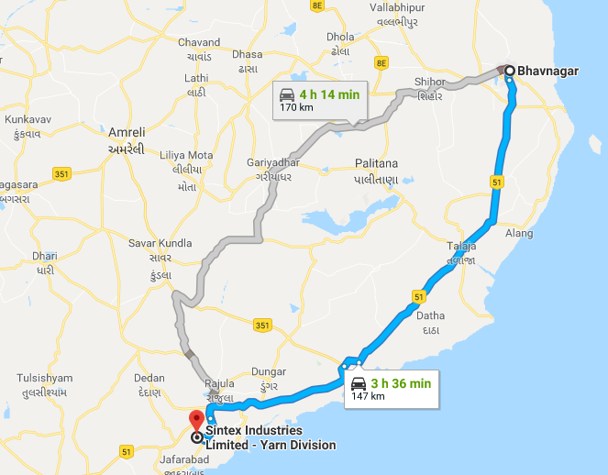
2. Rajkot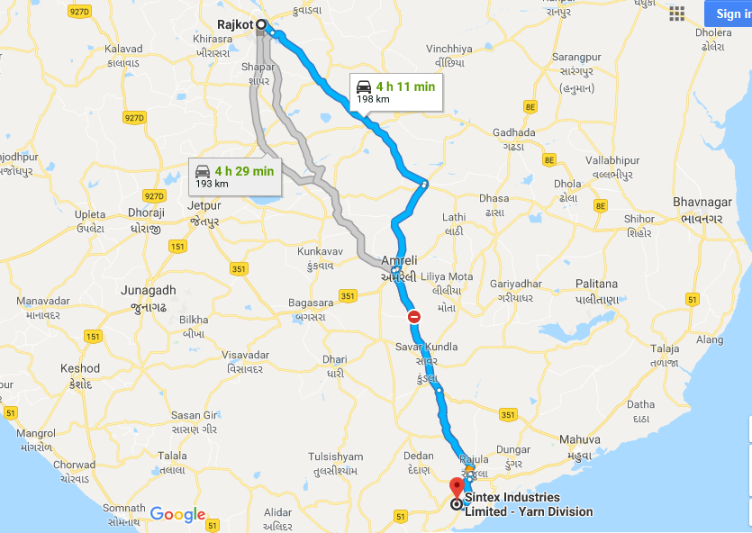
3. Ahmedabad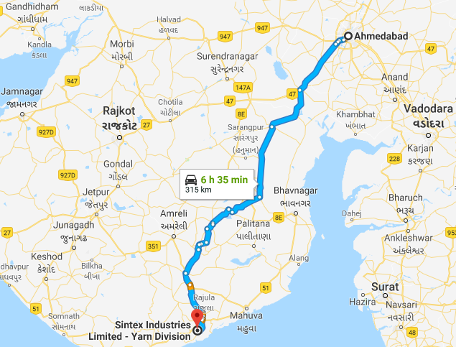
4. Diu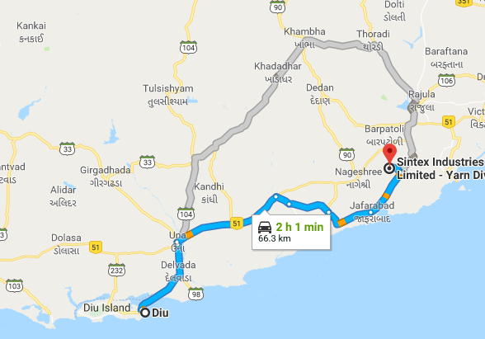
5. Vadodara